PHW250B Journal Club Problems 1 - ANSWERS
Causal inference and measures of disease

Questions about Arnold et al., 2017 (only read pages 1-4)

Problem 1. What were the health outcomes of this study?

Gastrointestinal illness
Upper respiratory illness
Any infectious symptom

Problem 2. Use information from the Introduction section of the paper to draw a DAG for this research question. Below, list the exposure and outcome, and variables that you believe are parents of the exposure and outcome in this study, including variables that were not measured in this study. Mark which variables were measured in this study. Use that information to complete the simple DAG below.

While it was not required to draw a complete DAG (instead, we asked for you to complete a simplified DAG listing an exposure, an outcome, and one confounder), a complete DAG for this study is presented here for your information/learning.

Many variables in this DAG could be listed as parents of both the exposure and outcome, such as any of the variables in the central oval (years of surfing experience, beach location, etc.). Any of these would suffice as the confounder for the simplified DAG as well
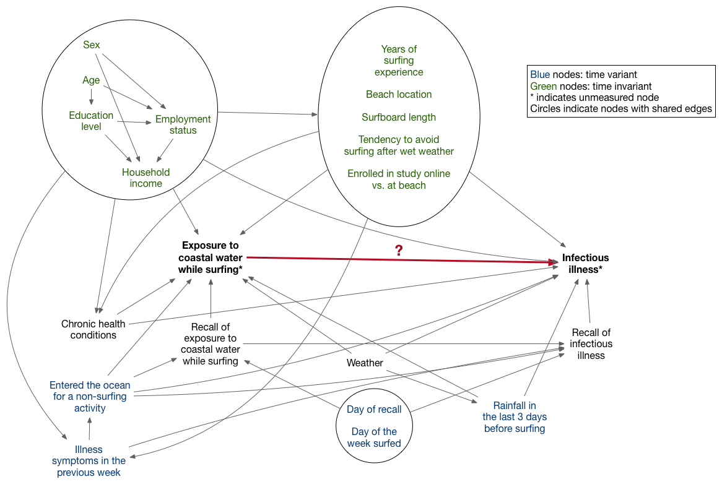

There are many different ways this DAG could be drawn, and there are certainly nodes and edges that could be included here that are not. For simplicity the DAG does not include U’s, but technically it should. In practice it would actually be best to draw separate DAGs for each outcome because, for example, gastrointestinal will have different causal pathways than skin infection (water consumption would affect gastrointestinal illness but not skin infection).

A key feature of this DAG to point out is that the bolded nodes are the nodes we’re truly interested in — actual exposure to coastal water while surfing and actual infectious illness. However, we don’t measure the actual exposure or outcome in this study but rather the reported exposures and outcomes. This is important and will come up later in this course when we learn about how to use DAGs to diagnose bias.

Problem 3. Define a structural causal model that corresponds to the simplified DAG below.

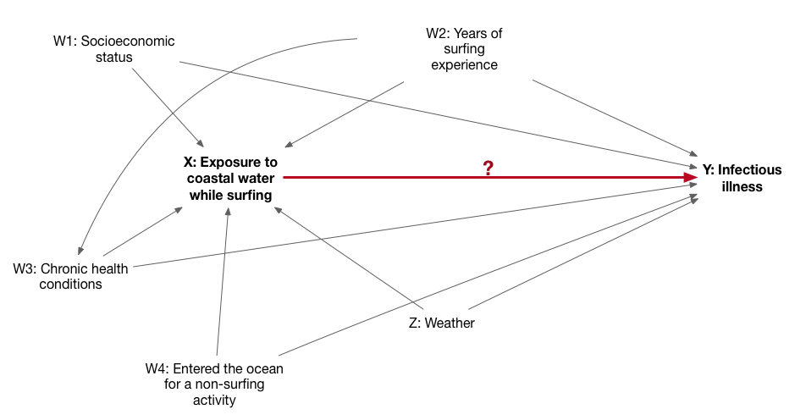

W1 = f_{W1} (U_{W1})
W2 = f_{W2} (U_{W2})
W3 = f_{W3} (W2, U_{W3})
W4 = f_{W4} (U_{W4})
X = f_{X} (Z, W1, W2, W3, W4, U_{X})
Y = f_{Y} (Z, W1, W2, W3, W4, X, U_{Y})
Z = f_{Z} (U_{Z})

Problem 4. Would you expect age, period, or cohort effects for this research question? Explain your answer briefly.

Age effects: People of different ages have differing levels of immunity to infectious diseases, so it is possible that age would be associated with risk of illness.

Cohort effects: It is unlikely that the risk of illness would differ according to year of birth for this particular outcome in this setting

Period effects: It is possible that the association may differ by season because different weather patterns affect the amount of contamination of coastal water that surfers are exposed to.

Problem 5. What is a limitation of using prevalence instead of incidence in this study?

Because prevalence captures both new and existing cases of illness, we would not be certain whether a prevalent case was due to a recent surfing episode, a previous surfing episode, or a different exposure.

Problem 6. What is an advantage of estimating incidence density instead of cumulative incidence in this study?

Cumulative incidence uses the population at risk as the denominator whereas incidence density uses the person-time at risk. Because surfing activity varied between individuals and within individuals at different times, it was easier to use person-time as a denominator because individual surfers contributed time at risk to both the exposed group (when they surfed) and the unexposed groups (when they didn’t surf).

Problem 7. Based on the description of the setting and study population, do you think this population was at a steady state?

No, it is unlikely that the numbers entering and exiting the population during the study were equal within levels of age, sex, and other determinants of infectious disease risk.

Problem 8. Based on your answer to the previous question, write down the appropriate formula for calculating person-time in this study. What assumption(s) does this formula require when used to calculate incidence density?
This is the formula for individual-level data:
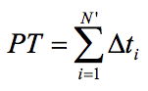

Assumptions:
- Independence of censoring and survival
- Lack of secular trends
- Risk of the event remains approximately constant over time during the interval of interest

Problem 9A. The study reports rates of illness among surfers in San Diego, California. We want to compare those rates to the rates of illness among surfers in San Francisco, California. For the purpose of this question, assume that the amount and type of surfing is the same in both cities. Describe why we would use standardization to compare rates in these two cities.

The surfers in San Diego and San Francisco may have different distributions of age, sex, or other variables that are associated with illness risk. Directly comparing illness rates between surfers in these two cities may lead to a false conclusion if the distributions of other variables are not the same. For example, if older age was associated with higher illness rates and surfers in San Diego tended to be older than surfers in San Francisco, the rates in San Diego would be higher due to the difference in age.

Question 9B. How would you go about performing direct standardization in this study?

- Decide which variable we want to standardize by (e.g., age) and then stratify the counts of illness events and population within levels of that variable for data on surfers from San Diego and San Francisco.
- Find data from a reference population (ideally of surfers if such data existed) with population counts stratified by the variable of interest.
- Estimate the expected number of people who were ill in each population using the stratified population counts from the population and the illness counts from San Diego and San Francisco.
- Estimate the adjusted rate in each population (total expected outcomes / total reference population)
- Compare adjusted rates between populations
- (repeat steps 1-5 with other variables of interest)

Question 9C. How would you go about performing indirect standardization?

- Decide which variable we want to standardize by (e.g. age) and then stratify the counts of illness events and population within levels of that variable for data on surfers from San Diego and San Francisco.
- Find data from a reference population (ideally of surfers if such data existed) with illness rates stratified by the variable of interest.
- Estimate expected number of people who were ill in each population using the stratified rates from the reference population and the population counts from San Diego and San Francisco.
- Estimate the total observed and expected outcomes for each population.
- Estimate the standardized incidence ratio in each population.
- (repeat steps 1-5 with other variables of interest)

